Fatima Jinnah Women University
Department of Software Engineering



SUBJECT: CLOUD COMPUTING
SUBMITTED TO: SIR WAQAS
SUBMITTED BY: ZUNAIRA NOOR
REGISTRATION NO: 2023-BSE-075
CLASS: BSSE V-B

ASSIGNMENT #01

- Screenshot of my Gitea repository (showing README listing name & roll number)
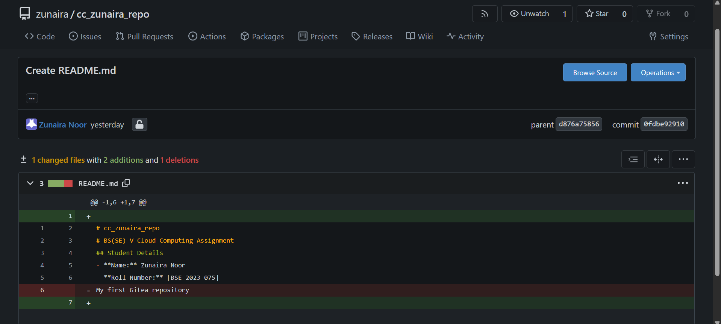
- GitHub assignment 1 repo link (with README and large files)
https://github.com/Zunaira-Noor123/assignment-1
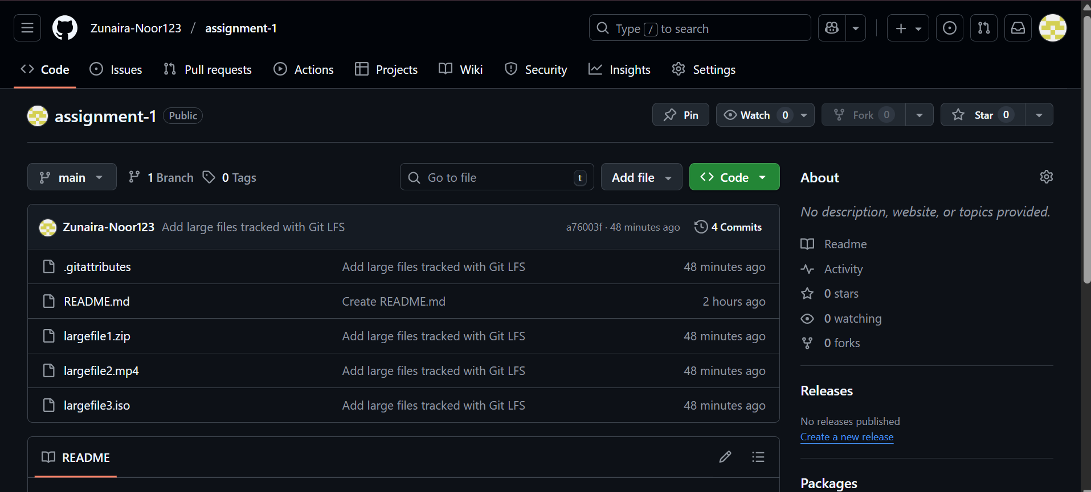
- Screenshot or output of git remote -v showing both remotes
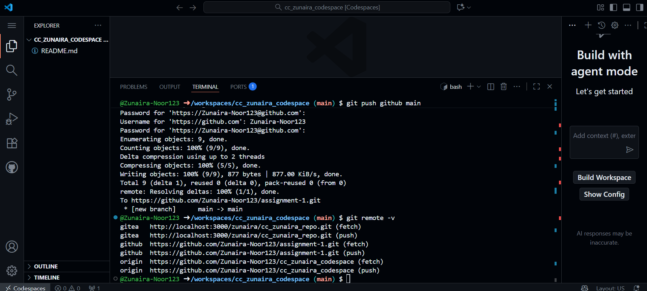
- GitHub Pages link to your CV/portfolio
https://zunaira-noor123.github.io/
https://zunaira-noor123.github.io/

